**BANK LOAN REPORT KEY PERFORMANCE INDICATORS**

1. **Total Loan Application**

SELECT distinct COUNT(id) AS Total_Applications FROM bank_loan_data

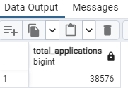

1. MTD Loan Applications

select to_char(issue_date,'month') as issue_month, count(distinct id) as total_monthly_applications from bank_loan_data

group by issue_month

order by total_monthly_applications desc

OR

SELECT COUNT(id) AS MTD_Total_Applications FROM bank_loan_data

WHERE MONTH(issue_date) = 12 AND YEAR(issue_date)=2021

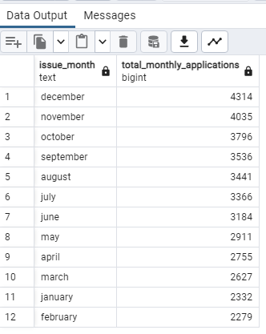

1. PMTD Loan Applications(Previous Month To Date, PMTD)

SELECT COUNT(id) AS Total_Applications FROM bank_loan_data

WHERE MONTH(issue_date) = 11

1. Total Funded Amount

SELECT SUM(loan_amount) AS Total_Funded_Amount FROM bank_loan_data

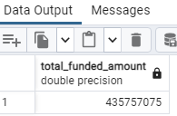

1. MTD Total Funded Amount

select to_char(issue_date,'month') as issue_month, SUM(loan_amount) as total_monthly_loan_disbursed from bank_loan_data

group by issue_month

order by total_monthly_loan_disbursed desc

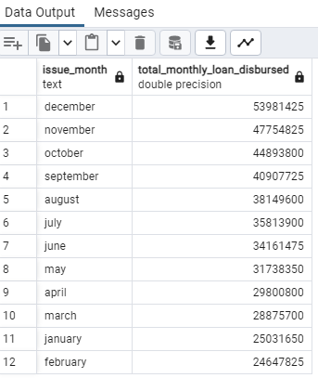

1. Total Amount Received

SELECT SUM(total_payment) AS Total_Amount_Collected FROM bank_loan_data

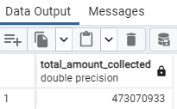

1. MTD Total Amount Received

select to_char(issue_date,'month') as issue_month, SUM(total_payment) as total_monthly_loan_collected_back from bank_loan_data

group by issue_month

order by total_monthly_loan_collected_back desc

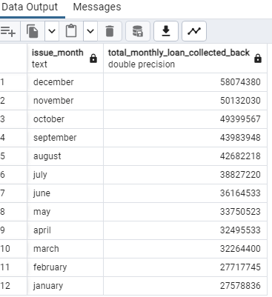

1. Average Interest Rate

SELECT cast(AVG(int_rate)*100 as decimal(10,2)) AS Avg_Int_Rate FROM bank_loan_data

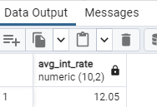

1. MTD Average Interest

SELECT cast(AVG(int_rate)*100 as decimal(10,2)) AS Avg_mtd_Int_Rate FROM bank_loan_data

where date_part('month', issue_date)=12 and date_part('year', issue_date)=2021

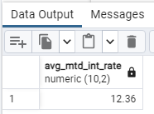

1. Previous MTD Average Interest

SELECT cast(AVG(int_rate)*100 as decimal(10,2)) AS Avg_pmtd_Int_Rate FROM bank_loan_data

where date_part('month', issue_date)=11 and date_part('year', issue_date)=2021

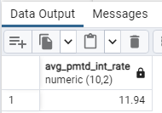

1. Avg DTI

SELECT cast(AVG(dti)*100 as decimal(10,2)) AS Avg_DTI FROM bank_loan_data

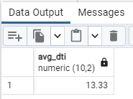

1. MTD Avg DTI

SELECT cast(AVG(dti)*100 as decimal(10,2)) AS MTD_Avg_DTI FROM bank_loan_data

where date_part('month', issue_date)=12 and date_part('year', issue_date)=2021

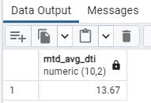

1. PMTD Avg DTI

SELECT cast(AVG(dti)*100 as decimal(10,2)) AS PMTD_Avg_DTI FROM bank_loan_data

where date_part('month', issue_date)=11 and date_part('year', issue_date)=2021

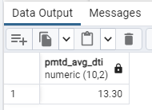

**GOOD LOAN ISSUED**

1. Good Loan Percentage

SELECT Cast((COUNT(CASE WHEN loan_status = 'Fully Paid' OR loan_status = 'Current' THEN id END) * 100.0) / COUNT(id) as decimal(10,2)) AS Good_Loan_Percentage

FROM bank_loan_data

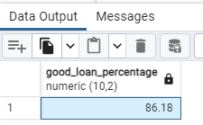

1. Good Loan Application

SELECT COUNT(id) AS Good_Loan_Applications FROM bank_loan_data

WHERE loan_status = 'Fully Paid' OR loan_status = 'Current'

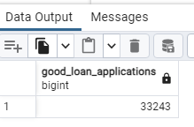

1. Good Loan Funded Amount

SELECT SUM(loan_amount) AS Good_Loan_Funded_amount FROM bank_loan_data

WHERE loan_status = 'Fully Paid' OR loan_status = 'Current'

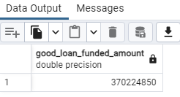

1. Good Loan Amount Recieved

SELECT SUM(total_payment) AS Good_Loan_amount_received FROM bank_loan_data

WHERE loan_status = 'Fully Paid' OR loan_status = 'Current'

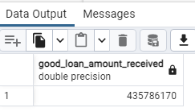

BAD ISSUED LOAN

1. Bad Loan Percentage

SELECT

cast((COUNT(CASE WHEN loan_status = 'Charged Off' THEN id END) * 100.0) /

COUNT(id) as decimal(10,2)) AS Bad_Loan_Percentage

FROM bank_loan_data

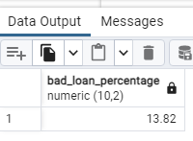

1. Bad Loan Application

SELECT COUNT(id) AS Bad_Loan_Applications FROM bank_loan_data

WHERE loan_status = 'Charged Off'

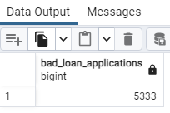

1. Bad Loan Funded Amount

SELECT SUM(loan_amount) AS Bad_Loan_Funded_amount FROM bank_loan_data

WHERE loan_status = 'Charged Off'

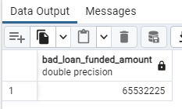

1. Bad Loan Amount Received

SELECT SUM(total_payment) AS Bad_Loan_amount_received FROM bank_loan_data

WHERE loan_status = 'Charged Off'

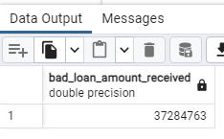

**LOAN STATUS**

SELECT

loan_status,

COUNT(id) AS LoanCount,

SUM(total_payment) AS Total_Amount_Received,

SUM(loan_amount) AS Total_Funded_Amount,

AVG(int_rate * 100) AS Interest_Rate,

AVG(dti * 100) AS DTI

FROM

bank_loan_data

GROUP BY

loan_status

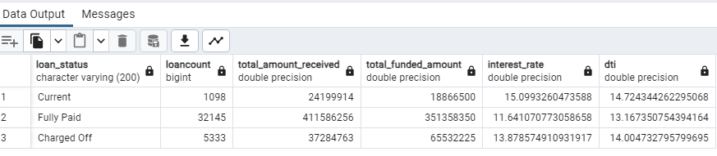

SELECT

loan_status,

SUM(total_payment) AS MTD_Total_Amount_Received,

SUM(loan_amount) AS MTD_Total_Funded_Amount

FROM bank_loan_data

where date_part('month', issue_date)=12

GROUP BY loan_status

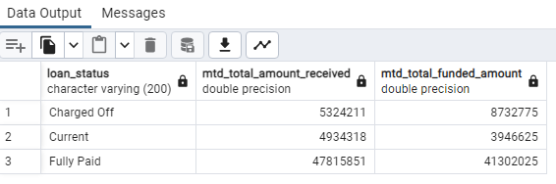

**BANK LOAN DETERMINANT REPORT**

MONTH

SELECT

to_char(issue_date,'month') as issue_month,

COUNT(id) AS Total_Loan_Applications,

SUM(loan_amount) AS Total_Funded_Amount,

SUM(total_payment) AS Total_Amount_Received

FROM bank_loan_data

GROUP BY issue_month

ORDER BY issue_month

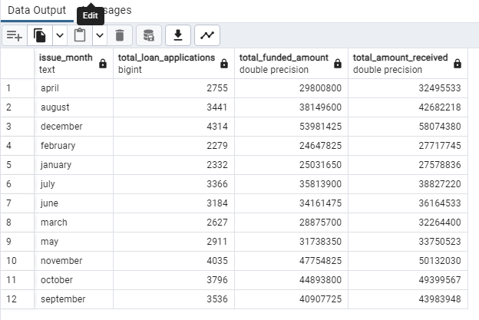

**STATE**

SELECT

address_state AS State,

COUNT(id) AS Total_Loan_Applications,

SUM(loan_amount) AS Total_Funded_Amount,

SUM(total_payment) AS Total_Amount_Received

FROM bank_loan_data

GROUP BY address_state

ORDER BY address_state

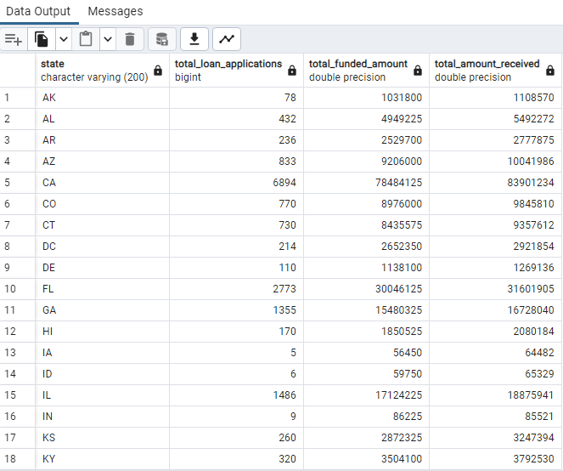

**TERMS OF PAYMENT**

SELECT

term AS Term,

COUNT(id) AS Total_Loan_Applications,

SUM(loan_amount) AS Total_Funded_Amount,

SUM(total_payment) AS Total_Amount_Received

FROM bank_loan_data

GROUP BY term

ORDER BY term

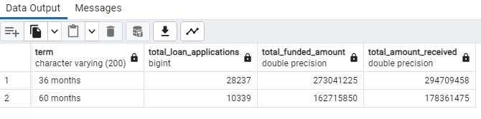

**EMPLOYEE LENGTH**

SELECT

emp_length AS Employee_Length,

COUNT(id) AS Total_Loan_Applications,

SUM(loan_amount) AS Total_Funded_Amount,

SUM(total_payment) AS Total_Amount_Received

FROM bank_loan_data

GROUP BY emp_length

ORDER BY emp_length

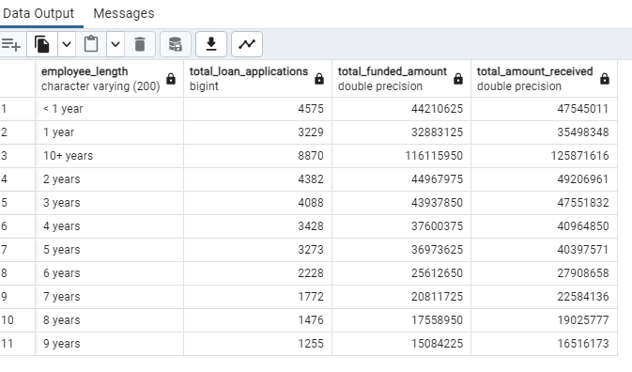

**PURPOSE**

SELECT

purpose AS PURPOSE,

COUNT(id) AS Total_Loan_Applications,

SUM(loan_amount) AS Total_Funded_Amount,

SUM(total_payment) AS Total_Amount_Received

FROM bank_loan_data

GROUP BY purpose

ORDER BY purpose

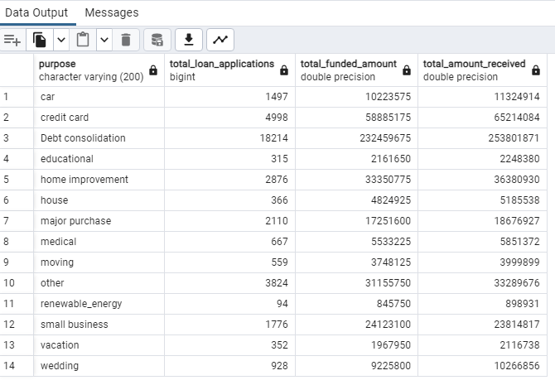

**HOME OWNERSHIP**

SELECT

home_ownership AS Home_Ownership,

COUNT(id) AS Total_Loan_Applications,

SUM(loan_amount) AS Total_Funded_Amount,

SUM(total_payment) AS Total_Amount_Received

FROM bank_loan_data

GROUP BY home_ownership

ORDER BY home_ownership

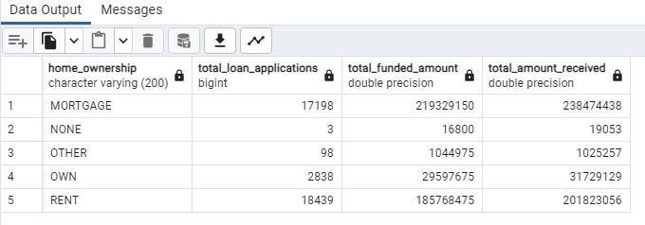

**SLICING GRADE BY PURPOSE**

SELECT

purpose AS PURPOSE,

COUNT(id) AS Total_Loan_Applications,

SUM(loan_amount) AS Total_Funded_Amount,

SUM(total_payment) AS Total_Amount_Received

FROM bank_loan_data

WHERE grade = 'A'

GROUP BY purpose

ORDER BY purpose

